 | EZEL NURSERY AND PRIMARY SCHOOL  Home Learning Program  www.ezelschool.com/homelearning.html
TOP CLASS

Week 1
MONDAY
 | Topics | Activities
Math | - Practice counting, patterns and addition without using a number line.  - Compare number | - Activity: Count 1-20.  Add:  - 1+0=  - 2+1=  - 4+2=  - 2+3=
English | - Learn new words  - Revise old words | - Vocabulary: book, black, bench, cake  Activity:  - Read and spell the words  - Write the words
Literacy | - Practice sounds and make new words | - Letters: A, B , C , D , E, F , G  - Say the sounds of letter A, B , C , D , E, F , G  - Say words that begin with letter A, B, C , D, E, F, G
Read the story  (Parent should read the story for the child) | Baby Crying by Ivor Sempa  The mother of a baby left the baby home and went to the market.  when she went she delayed and spent a lot of time away.  The baby got angry and started crying until the mother came back
TUESDAY
 | Topics | Activities
Math | - Practice counting, patterns and addition without using a number line.  Compare number | - Count from 1 - 20  Feel in the missing numbers  11, _____, 13, 14 , _____ , ______, 17
English | Revise Story words and learn new words | - Vocabulary: baby, home, mother, cry  Activity:  Read and spell the words. Write the words
Literacy | Practice sounds and new words | - Sight words: do, we, him, her  Activity:  - Read and spell the words. Write the words.
WEDNESDAY
 | Topics | Activities
Math | - Practice counting, patterns and addition without using a number line.  Compare number | - Count from 1 to 20  Add:  - 5+2=  - 6+2=  - 7+0=  - 3+7=  - 0+9=
English | Revise Story words and learn new words | - Vocabulary: baby, home, mother, cry  Activity: Read and spell the words. Write the words
Literacy | Practice sounds and new words | - Sight Words: do , we , him , her  Write down the sight words.
THURSDAY
 | Topics | Activities
Math | - Practice counting, patterns and addition without using a number line.  - Compare number | - Count from number 1 – 20  - Compare using greater than (>) and less than (<)  1. 19 ____ 14  2. 1 _____10  3. 13 ____ 16
English | - English - Revise story words.  - Learn new story words. | - Vocabulary: baby, home, mother, cry, market  Activity: Read and spell the words. Write the words
Literacy | Practice sounds and new words | - Sight words: do, we , him , her  Activity:  - Read and spell the words.  - Write sentences with the words
FRIDAY
 | Topics | Activities
Math | - Practice counting, patterns and addition without using a number line. - Compare numbers. | - Count from number 1 to 20  - Write the number that come before and after the following: 12, 6, 15, 19, 8  Example: 9 , 10 , 11 ; 9 comes before 10 and 11 comes after 10
English | - English - Revise story words.  Learn new story words. | - Vocabulary: baby, home, mother, cry, market, went, spent  - Activity: Read and spell the words. Write the words
Literacy | Practice letter sounds and the new word | - Sight words: do, we , him , her  Activity:  - Read and spell the words.  - Write sentences with the words

Note: Dear parents/caregivers always make sure that
- You explain new words to your child.
- Recite new words as many times as you can
- Be kind and patient with your child, they cannot learn new things in one day.
- Provide your child with books, pencils, crayons and papers.

ACTIVITIES
Activity 1 (numbers): Count and write
 | =
 | =
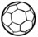 | =
 | =

Activity 2 (environment): Draw a picture of the following words.
- Shorts 2. Dress 3. Socks
Activity 3 (Language): Trace the letters
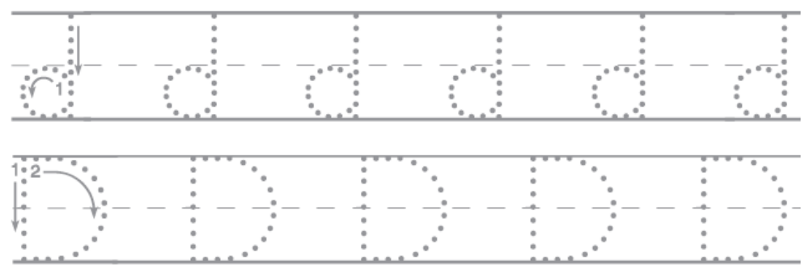
Activity 4 (Environmental): Read the words and match to the picture
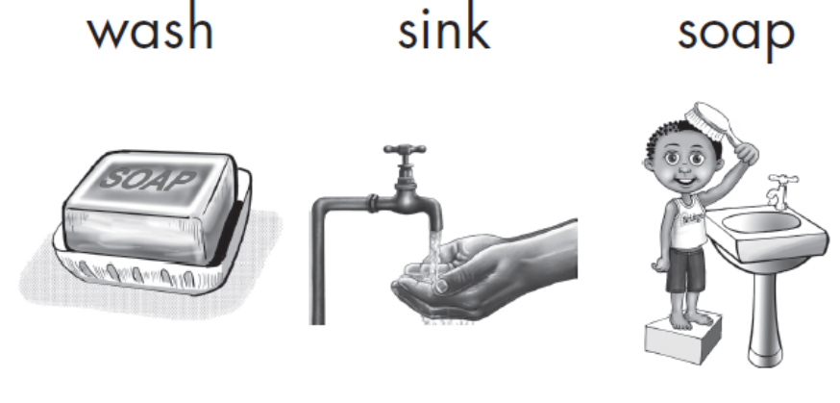
Activity 5 (numbers): Count the Objects and write the number in the box.
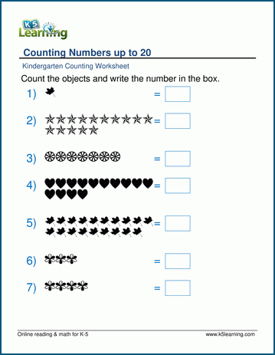 | =
 | =
 | =
 | =

Activity 6 (Language) : Read and write the following words in your book.
- she 2. her 3. his 4. in 5. on 6. this

Activity 7 (Language): Trace the letters
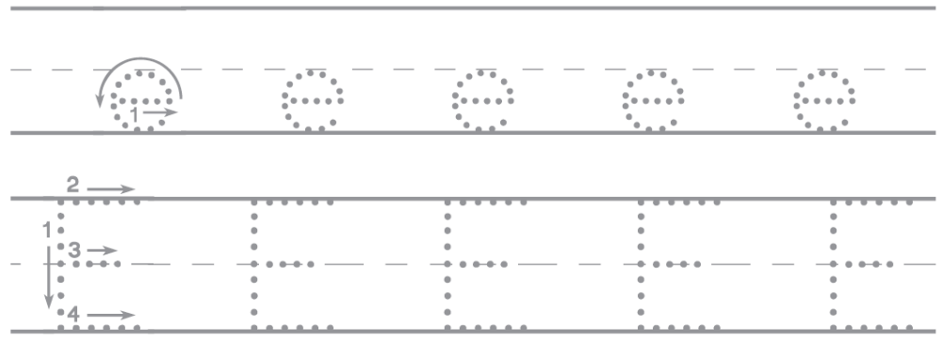
Activity 8 (environment): Read the words. Draw a line to match the words to the pictures
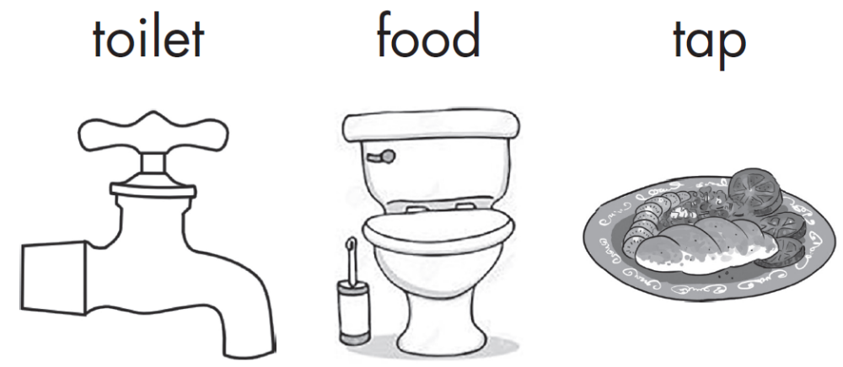

Activity 9: Write letters from A – Z
Activity 10: Write letters from a – z
Activity 12: write numbers from 1 – 20

For more information, call:
Agule area and all other areas | Kameke Area
0772644523 | 0758650099 | 077074014 | 0786560989 [Director God Help Junior School]

